Hello World RESTful Web Service:

SpringLearnApplication.java
package com.cognizant.spring_learn;
import org.springframework.boot.SpringApplication;
import org.springframework.boot.autoconfigure.SpringBootApplication;
import org.springframework.context.ApplicationContext;
import org.springframework.context.support.ClassPathXmlApplicationContext;
@SpringBootApplication
public class SpringLearnApplication {
public static void main(String[] args) {
SpringApplication.run(SpringLearnApplication.class, args);
displayCountry();
}
public static void displayCountry() {
ApplicationContext context =
new ClassPathXmlApplicationContext("country.xml");
Country country =
context.getBean("country", Country.class);
System.out.println(country);
}
}
HelloController.java
package com.cognizant.spring_learn.controller;
import org.slf4j.Logger;
import org.slf4j.LoggerFactory;
import org.springframework.web.bind.annotation.GetMapping;
import org.springframework.web.bind.annotation.RestController;
@RestController
public class HelloController {
private static final Logger LOGGER =
LoggerFactory.getLogger(HelloController.class);
@GetMapping("/hello")
public String sayHello() {
LOGGER.info("START");
LOGGER.info("END");
return "Hello World!!";
}
}
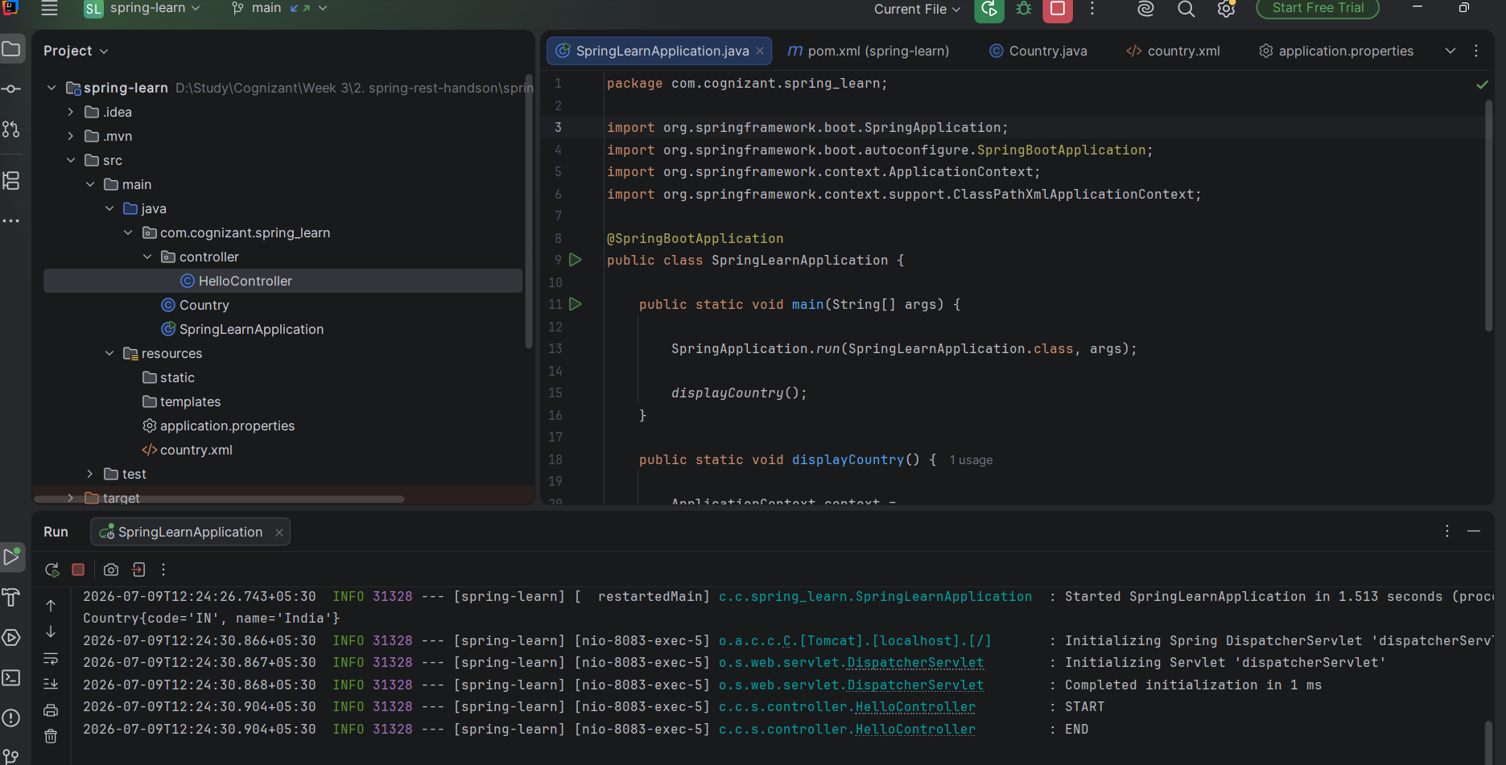
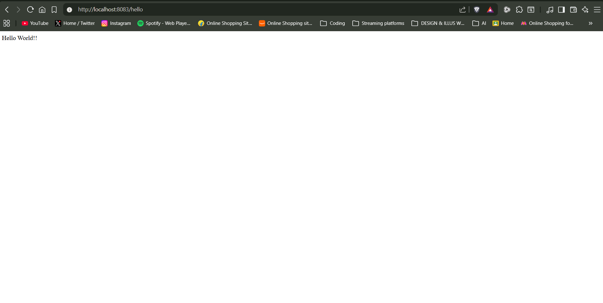

REST – Country Web Service:
CountryController.java
package com.cognizant.spring_learn.controller;
import com.cognizant.spring_learn.Country;
import org.springframework.context.ApplicationContext;
import org.springframework.context.support.ClassPathXmlApplicationContext;
import org.springframework.web.bind.annotation.RequestMapping;
import org.springframework.web.bind.annotation.RestController;
@RestController
public class CountryController {
@RequestMapping("/country")
public Country getCountryIndia() {
ApplicationContext context =
new ClassPathXmlApplicationContext("country.xml");
return context.getBean("country", Country.class);
}
}

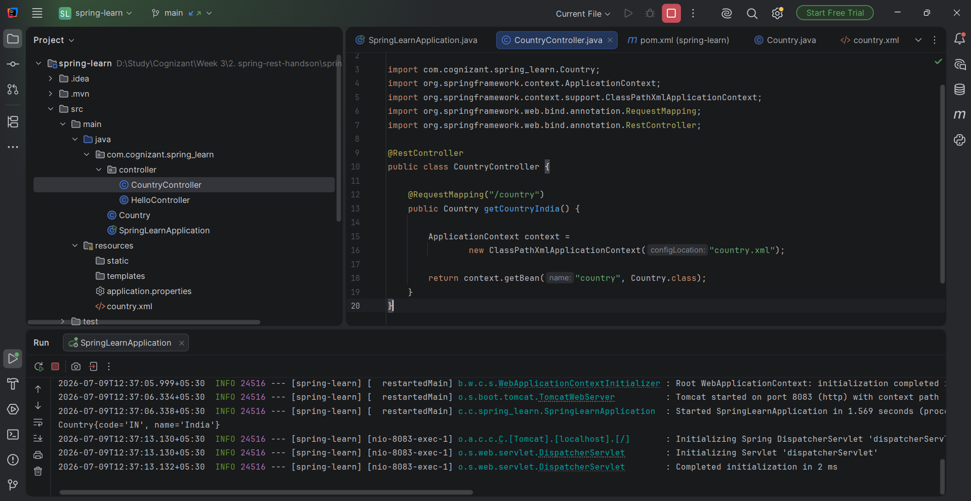

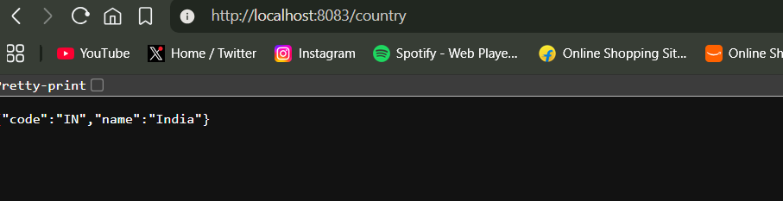

REST – Get country based on country code:
SpringLearnApplication.java
package com.cognizant.spring_learn;
import org.springframework.boot.SpringApplication;
import org.springframework.boot.autoconfigure.SpringBootApplication;
@SpringBootApplication
public class SpringLearnApplication {
public static void main(String[] args) {
SpringApplication.run(SpringLearnApplication.class, args);
}
}

CountryController.java
package com.cognizant.spring_learn.controller;
import com.cognizant.spring_learn.Country;
import com.cognizant.spring_learn.service.CountryService;
import org.springframework.beans.factory.annotation.Autowired;
import org.springframework.web.bind.annotation.*;
@RestController
public class CountryController {
@Autowired
private CountryService countryService;
@GetMapping("/countries/{code}")
public Country getCountry(@PathVariable String code) {
return countryService.getCountry(code);
}
}

country.xml
<?xml version="1.0" encoding="UTF-8"?>
<beans xmlns="http://www.springframework.org/schema/beans"
xmlns:xsi="http://www.w3.org/2001/XMLSchema-instance"
xsi:schemaLocation="
http://www.springframework.org/schema/beans
https://www.springframework.org/schema/beans/spring-beans.xsd">
<bean id="countryList" class="java.util.ArrayList">
<constructor-arg>
<list>
<bean class="com.cognizant.spring_learn.Country">
<property name="code" value="IN"/>
<property name="name" value="India"/>
</bean>
<bean class="com.cognizant.spring_learn.Country">
<property name="code" value="US"/>
<property name="name" value="United States"/>
</bean>
<bean class="com.cognizant.spring_learn.Country">
<property name="code" value="DE"/>
<property name="name" value="Germany"/>
</bean>
<bean class="com.cognizant.spring_learn.Country">
<property name="code" value="JP"/>
<property name="name" value="Japan"/>
</bean>
</list>
</constructor-arg>
</bean>
</beans>

CountryService.java
package com.cognizant.spring_learn.service;
import com.cognizant.spring_learn.Country;
import org.springframework.context.ApplicationContext;
import org.springframework.context.support.ClassPathXmlApplicationContext;
import org.springframework.stereotype.Service;
import java.util.List;
@Service
public class CountryService {
private final List<Country> countryList;
@SuppressWarnings("unchecked")
public CountryService() {
ApplicationContext context =
new ClassPathXmlApplicationContext("country.xml");
countryList = (List<Country>) context.getBean("countryList");
}
public Country getCountry(String code) {
for (Country country : countryList) {
if (country.getCode().equalsIgnoreCase(code)) {
return country;
}
}
return null;
}
}
